Phase 1 · Design & Orient
Exercise 2: Project Genesis: /init and the CLAUDE.md Constitution
Dev cycle | Design (project setup)
CC features | /init, CLAUDE.md memory file, the # memory shortcut, @file references
Time | 35 min
You produce | An ExpenseFlow project folder, a Python venv, and a hand-tuned CLAUDE.md

Objective
Create the project and give Claude its standing instructions. CLAUDE.md is the agent's constitution for this repository: it is read at the start of every session and anchors your stack, conventions, and the things Claude must not touch. A good CLAUDE.md is the single highest-leverage file you will write all course.
Walk-through
1 | Scaffold the folder and environment
Create the project, a virtual environment, and install the stack yourself so you understand the ground truth before Claude touches anything. The only real difference between platforms is how you create and activate the venv.
Windows · PowerShell
PS> mkdir expenseflow
PS> cd expenseflow
PS> python -m venv .venv
PS> .\.venv\Scripts\Activate.ps1
PS> pip install fastapi "uvicorn[standard]" sqlalchemy httpx python-dotenv pytest
PS> git init
macOS / Linux · bash or zsh
$ mkdir expenseflow
$ cd expenseflow
$ python3 -m venv .venv
$ source .venv/bin/activate
$ pip install fastapi "uvicorn[standard]" sqlalchemy httpx python-dotenv pytest
$ git init
VALIDATE Your prompt now shows (.venv). pip list includes fastapi, uvicorn, sqlalchemy, httpx, pytest. A hidden .git folder exists. From here on, with the venv active, plain python works on both platforms.
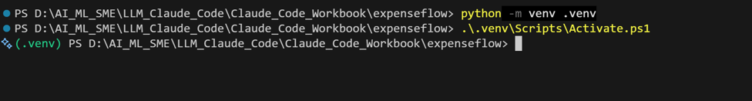
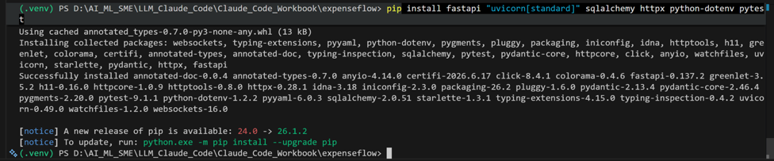

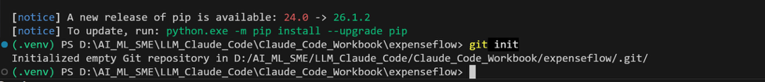
2 | Launch Claude Code and run /init
Start Claude Code from inside the project folder, then run /init. Claude inspects the directory and drafts a CLAUDE.md for you. Review what it proposes rather than accepting blindly.
The CLAUDE.md file serves two main purposes:
- Guides Claude through your codebase, pointing out important commands, architecture, and coding style
- Allows you to give Claude specific or custom directions
Run in terminal
PS> claude
Inside the session
PS> /init
VALIDATE A CLAUDE.md file appears in the project root. Open it in VS Code: it should mention Python and the libraries you installed.
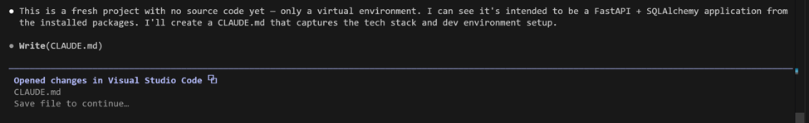
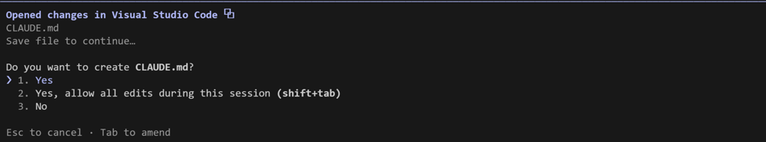
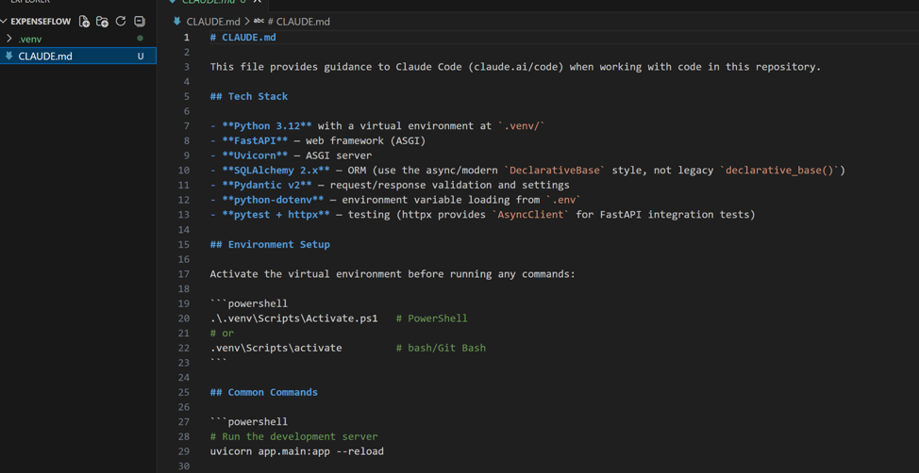

3 | Rewrite CLAUDE.md to be specific
The generated file is generic. Replace its body with a precise brief. Specificity here is what stops Claude from wandering for the rest of the build. Paste the following into CLAUDE.md, editing freely.
Create / paste → CLAUDE.md
# ExpenseFlow API

## What this is
A small expense submission and approval API. PoC, not production.
One user journey: submit an expense, convert it to a base currency, approve or reject it.

## Stack
- Python 3.12, FastAPI, Uvicorn
- SQLAlchemy ORM on SQLite (file: expenseflow.db) for the PoC
- httpx for the external FX rate call
- pydantic v2 for request and response models
- pytest for tests

## Conventions
- Layout: app/main.py, app/db.py, app/models.py, app/schemas.py, app/routes.py
- Type hints on every function. Docstrings on every endpoint.
- Money is stored as integer minor units (paise / cents), never float.
- Base currency is INR. All amounts are normalised to base on write.
- Never hardcode secrets. Read them from environment variables via python-dotenv.

## Run and test
- Run: python -m uvicorn app.main:app --reload
- Test: python -m pytest -q

## Do not touch
- Do not edit .venv, .git, or expenseflow.db directly.
- Do not add new third-party dependencies without telling me first.
- Do not invent endpoints that are not in the brief.
VALIDATE Save CLAUDE.md. The 'Money as integer minor units' and 'Do not add dependencies without telling me' lines are the two that will pay off most: they pre-empt the two most common AI mistakes.
4 | Prove Claude is reading it
Start a fresh prompt and ask a question whose answer only exists in CLAUDE.md. This confirms the constitution is live.
Type this prompt into Claude Code
Without writing any code: how should money be stored in this project, and what is the base currency? Answer from CLAUDE.md only.
VALIDATE Claude answers 'integer minor units (paise)' and 'INR'. If it does not, your CLAUDE.md did not save in the project root: check the path.
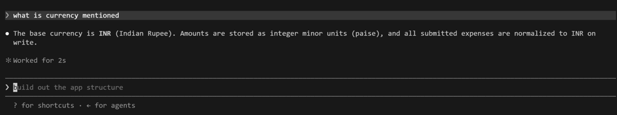

5 | Add an in-session memory
You can append durable instructions mid-session with the # shortcut: type # followed by the instruction and it is written into CLAUDE.md. Add one now.
Inside the session
/
VALIDATE Open CLAUDE.md again: the new line has been appended. The # shortcut is the fastest way to encode a lesson the moment you learn it.
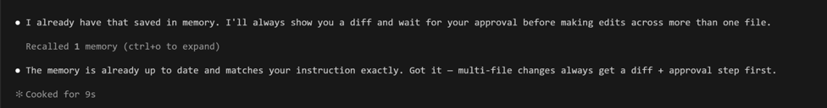
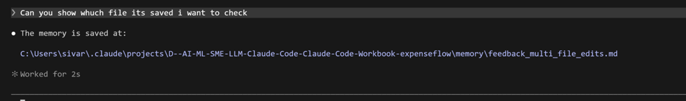
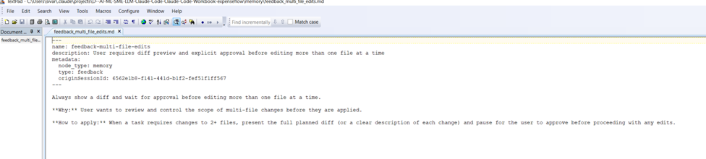
What success looks like
- CLAUDE.md describes ExpenseFlow precisely: stack, file layout, money rule, base currency, and explicit do-not-touch boundaries.
- You can demonstrate that a new prompt answers correctly from CLAUDE.md alone.
- You know two ways to update the constitution: edit the file directly, or use the # shortcut in-session.
Common pitfalls (Windows and macOS)
- If .\.venv\Scripts\Activate.ps1 is blocked on Windows, set the per-session execution policy as in Exercise 1, then re-run it. On macOS or Linux the equivalent is source .venv/bin/activate, which needs no policy change.
- CLAUDE.md only applies to the folder it sits in. If you start claude from the wrong directory, it will not be loaded.
- Resist the urge to make CLAUDE.md enormous. Tight and specific beats long and vague.
Stretch goal
Add a user-level memory at ~/.claude/CLAUDE.md with your personal defaults (for example, 'prefer ruff for formatting, explain trade-offs before large refactors'). Project CLAUDE.md and user CLAUDE.md stack together.

